VM Automation

1. Sign in to the [Azure Portal](https://portal.azure.com/#home) using your preferred web browser.

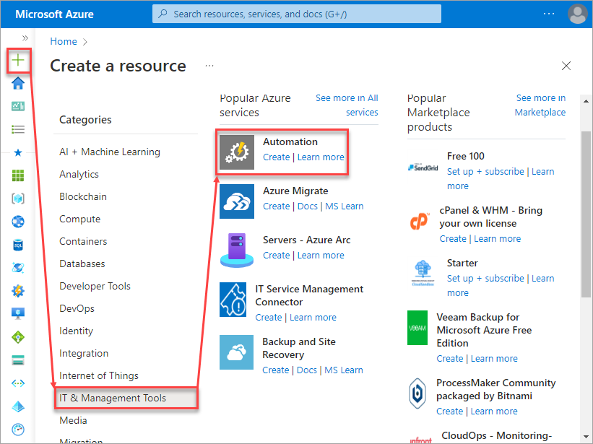

2.Create Automation Account

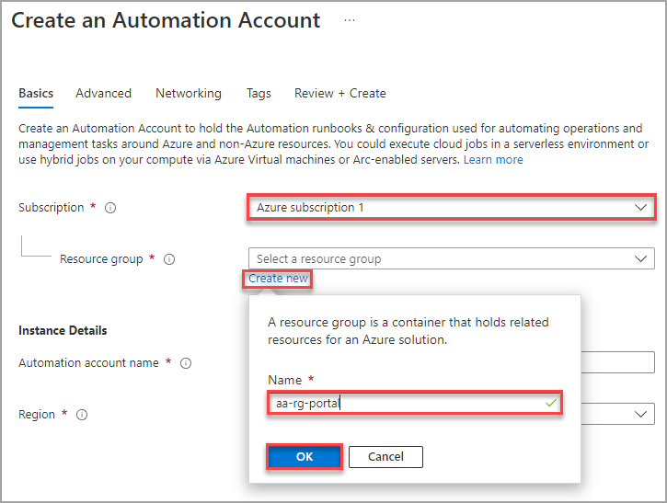

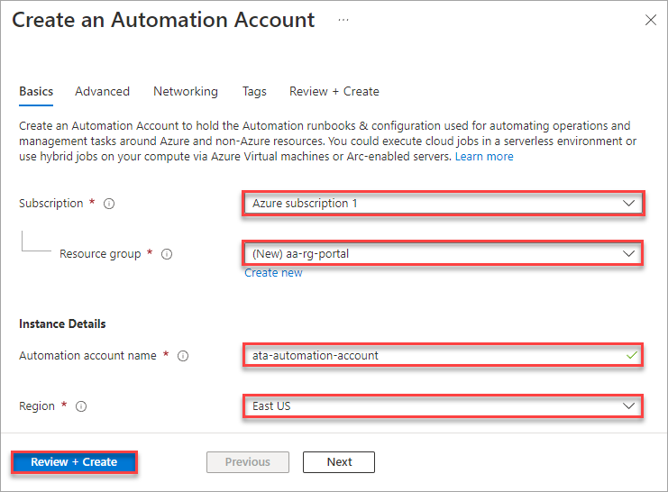

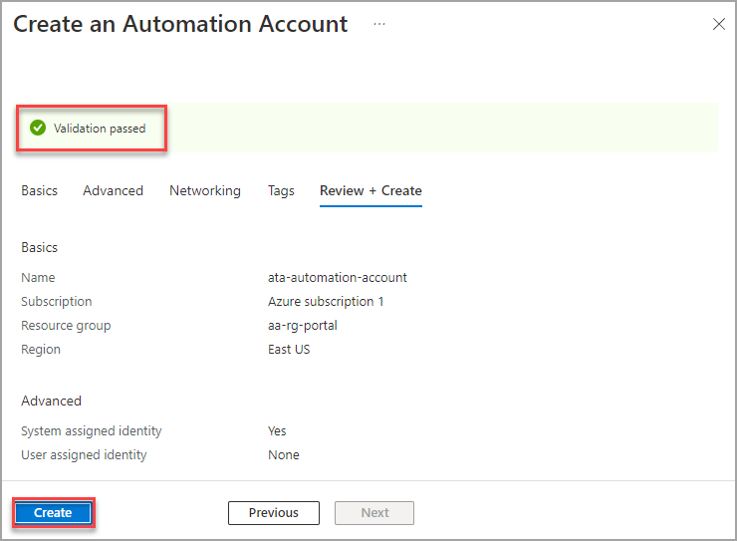

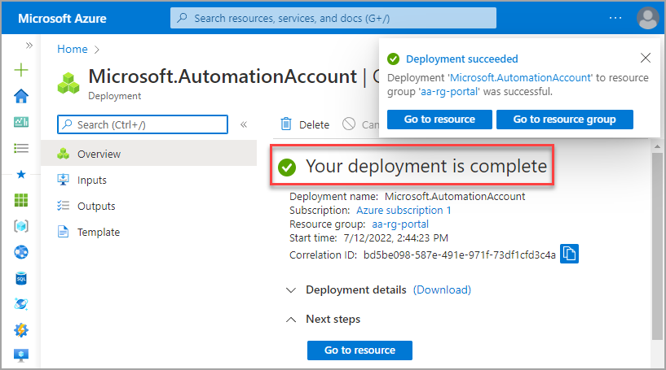

3. Now Navigate back to the [Automation accounts blade](https://portal.azure.com/#view/HubsExtension/BrowseResource/resourceType/Microsoft.Automation%2FAutomationAccounts) and click on the name of your Automation account.

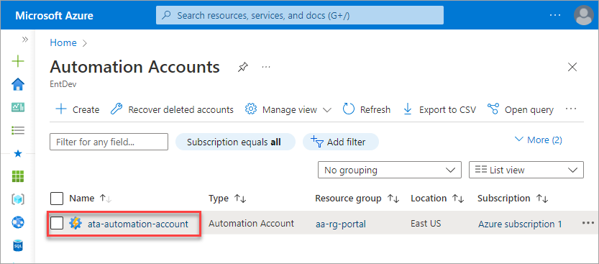

4. Under the Process Automation section, click Runbooks and the Create a runbook button near the top of the page.

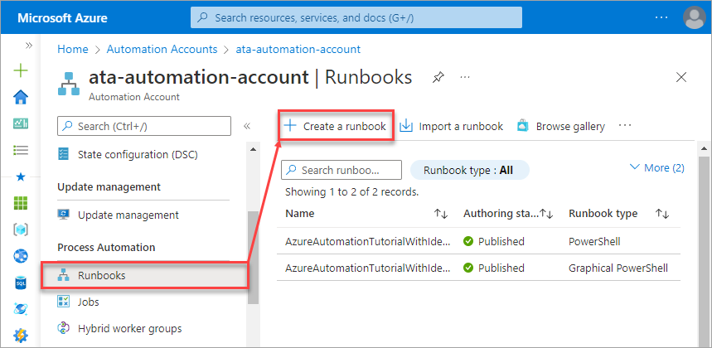

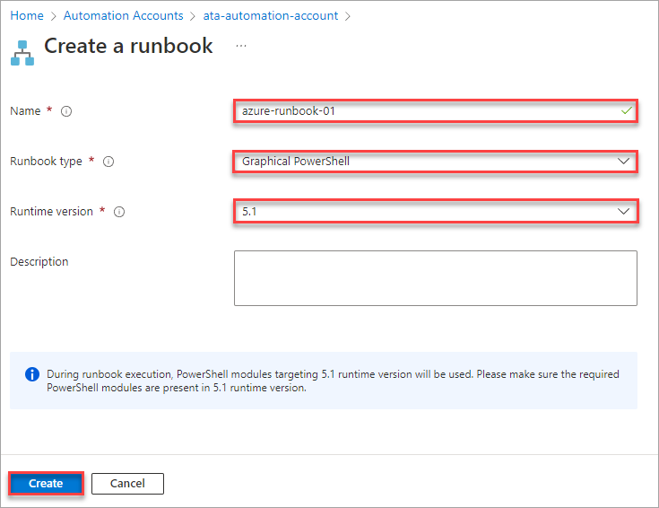



above marked line we have select PowerShell option



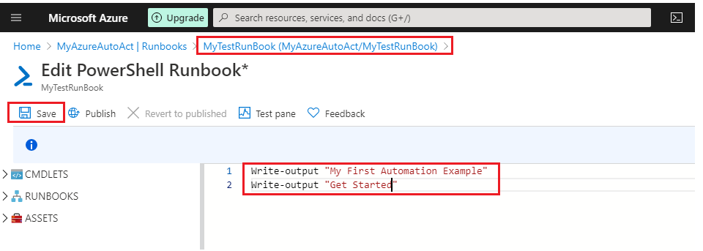

Click on powershell on runbook created window.

### 5. Editing the Runbook and insert below commands

Connect-AzAccount -Identity

Start-AzVM -ResourceGroupName "iAgriPOC-01" -Name "iAgri-Poc-Vm"

### 6. Testing the Runbook

You’ve created and configured a runbook, but does it work? To find out, the editor has a test pane where you can safely execute the runbook for testing.

1. Click Test Pane at the top of the canvass.

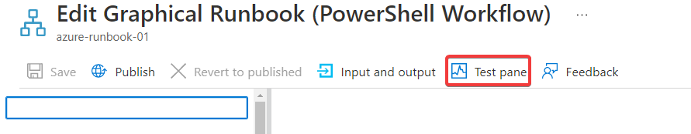

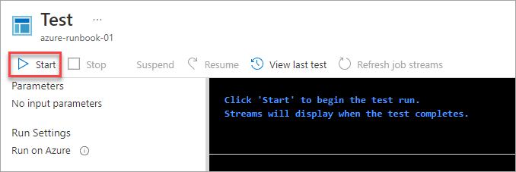



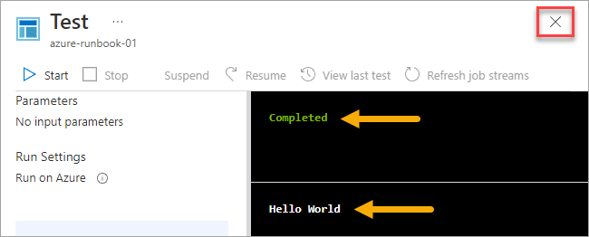



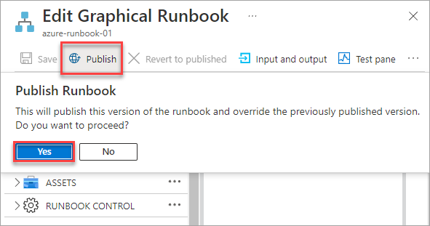

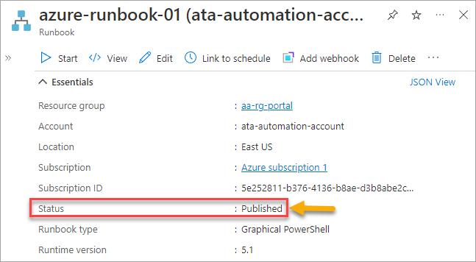

For Schedule time

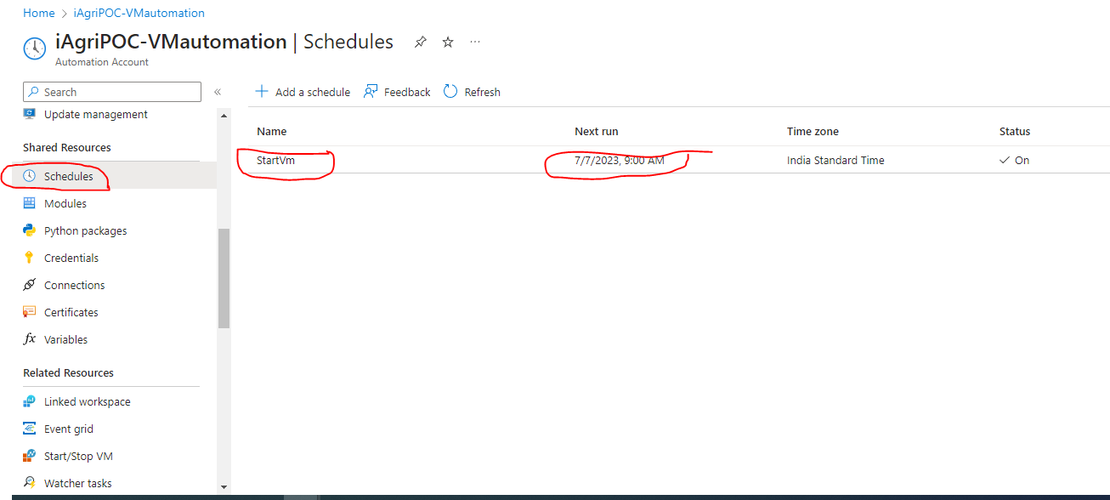

For Reference link is below :-

https://adamtheautomator.com/azure-runbook/